Project 3

In order to estimate the bounds for our big M constraint, we considered training a series of linear models, firstly with one predictor at a time, the other with a combination of 2-3 predictors, and the last model with all predictors at the same time.

Simultaneously we cached the coefficient values of each model. Finally, we evaluated the maximum absolute value of these coefficients and multiplied it with 10 to come up with our first estimate of M value.

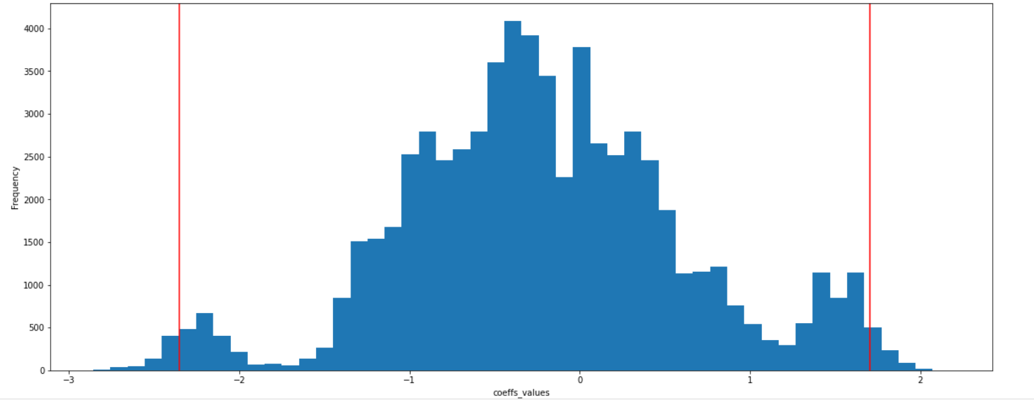

The coefficient values trained for the given target were primarily between -2.35 and 1.7, therefore we further gain confidence on our initial assumed value of 20 for BIg m bounds

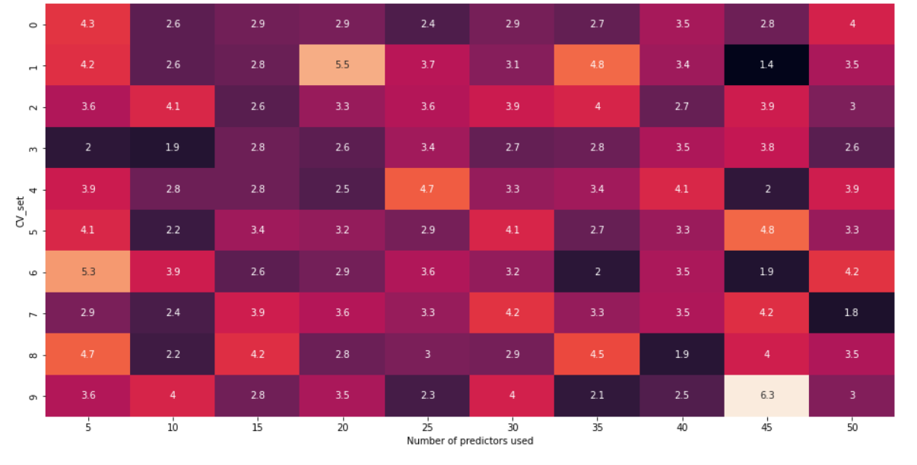

Heatmap plot of errors obtained on different cv_sets while training with variable number of predictors

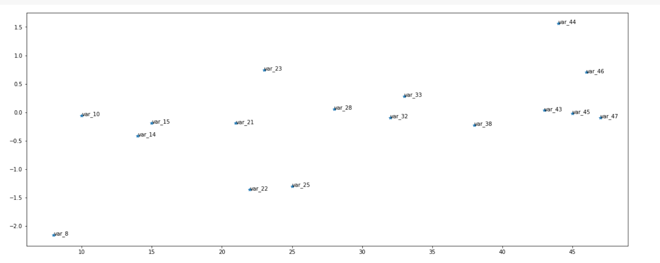

Variable and their associated coefficients values generated after training a LASSO linear model

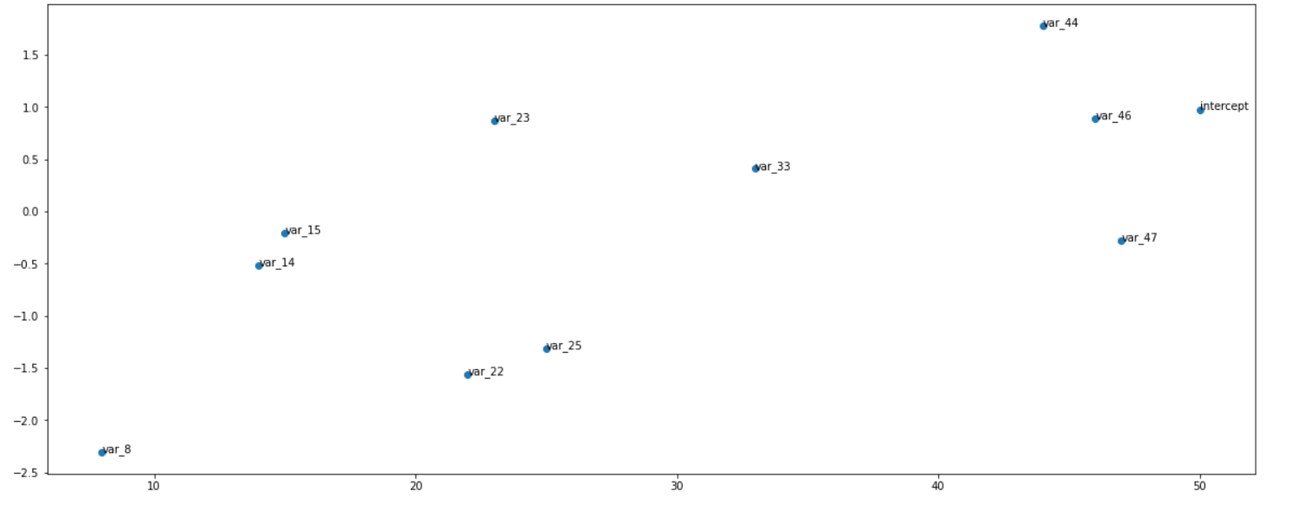

Variable and their associated coeff values after training a Big M based numerical optimization objective